Parental Alienation Is A Modern Reality Harming Children – And Families – In Malta

By Johnathan Cilia
February 28, 2021 at 3:44 am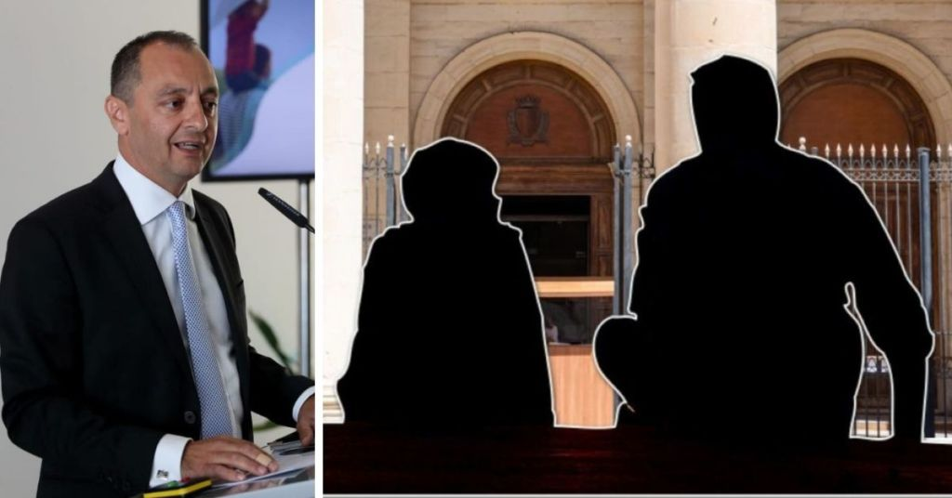

Families falling apart is nothing new for society, with the state offering a number of remedies to ensure the situation does not escalate and all parties are treated fairly.
But a situation that more and more parents are speaking out about seems to be more commonplace than first expected.
Parental alienation is used to describe a situation where one parent attempts to negatively influence their children against the other parents; it can become so grievous that the child is withheld from seeing the “other” parent for long periods.
This can lead to children rejecting one of their parents and not wanting to have a relationship with them.
One Maltese group aimed at raising awareness on this phenomenon said hundreds of families are being affected by this, and the government has now set up a National Technical Committee to advise on this.
Lovin Malta spoke to Andy Ellul, the chairperson of this technical committee, to see what the national strategy is to ensure families aren’t being torn apart by one parent.
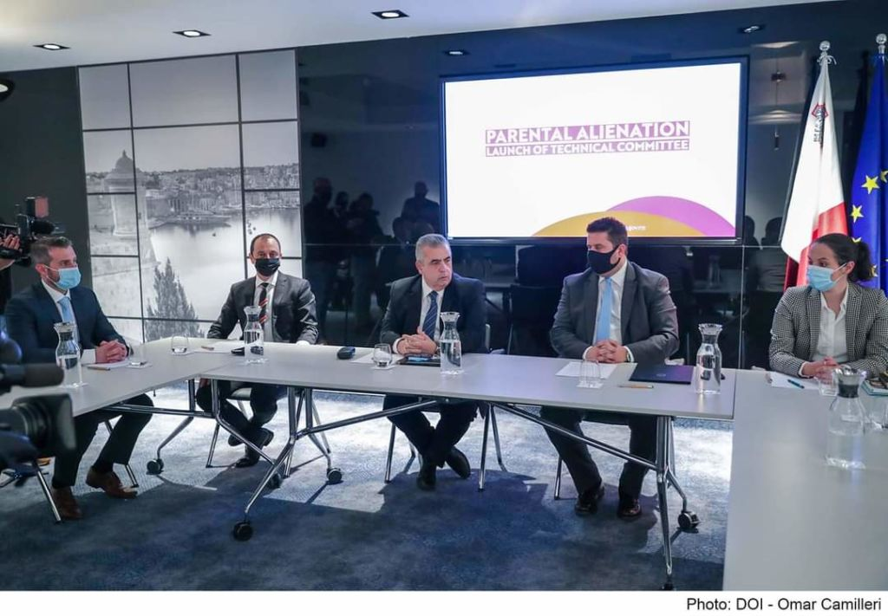
The technical committee

LM: How would you describe parental alienation exactly?
AE: Parental alienation is the term used in research referring to the situation in which one parent engages in parental alienation strategies and behaviours so as to lead their children to unjustly reject their relationship with the other parent, known as the targeted parent.
Research shows that there needs to be four factors for such a situation to be classified as a case of parental alienation: (i) that the child previously enjoyed a positive relationship with the targeted parent, (ii) absence of abuse or neglect on the part of the targeted parent, (iii) use of recognised alienating behaviours by the alienating parent, and (iv) exhibition of alienation behaviour by the child.
Many groups in Malta have been consistently raising awareness on parental alienation both on media platforms as well as with key stakeholders such as Ministers, members of the judiciary, advocates, psychologists and other professionals. They have also formed support groups. Through their awareness-raising efforts, parental alienation is being picked up by lawyers and is increasingly being mentioned in court cases.
However, few professionals have the expertise to tackle such cases and to work with the parties involved.

LM: What are the risks of this type of alienation?
AE: The danger of parental alienation is that, in most cases, the alienator learns how to use the court system in his/her favour to further perpetrate this form of abuse. Alienators in parental alienation cases often disregard the court’s authority and orders as, unfortunately, they learn that there are no real penalties for them in doing so. The length in the proceedings and the lengthy periods between one sitting and the next, aids the alienator in reaching his/her aim. Thus, alienators are a threat to the justice system as the Court appears weak in their regard. Targeted parents soon become disillusioned and lose faith in the justice system, even though they may continue with the proceedings for the sake of their children. Many know that until the proceedings reach the final stage and a judgment is delivered, years would have gone by – years missed from their children’s lives.
Often children, victims of parental alienation, are caught up in a conflict of loyalties between the parents and choose to side with the alienator as a form of coping mechanism. Other children may have been brainwashed to the extent that they genuinely believe they are better off without the targeted parent. In any case, these are children that are also victims of abuse with their wellbeing being constantly hindered.
This is not an issue affecting one stratum of society, it actually affects parents from all walks of life. Since my appointment as Chairman of the National Committee, I have been contacted by professors, doctors, lawyers and other professionals all complaining of parental alienation. The National Committee however will not go into specific cases and will not give advice or assist individuals.
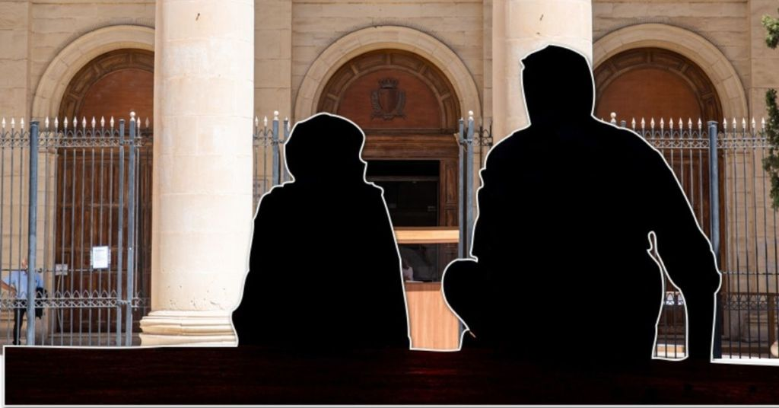
LM: Is parental alienation a growing problem in Malta in 2021?
From a practicing lawyer’s point of view, what I can say with certainty is that this is a reality, which I have witnessed from my first day as a practicing lawyer at the Family Court.
Rather than saying that the problem is growing in Malta, I would say that there is more awareness nowadays about this ugly phenomenon. The truth is that it is only recently that professionals are talking about the concept of parental alienation.
LM: How many families would you say this affects in Malta?
AE: To answer this question we need to have at hand the findings of the study the Technical Committee is commissioning. Following the results of this study, we will then proceed to launch a public consultation, to understand better the local scenario.
LM: Do we know, on average, how long it takes for a family court case to go from start to finish?
AE: This much depends on a case by case basis.
In my experience as a lawyer, I can say that I concluded personal separation proceedings in a matter of days while others took from five to seven years to conclude. Delays can be attributed to various factors, including delaying tactics by the parties involved – and they can be very detrimental.
LM: During the pandemic, some parents have said they are being made to pay maintenance when they can’t afford it, or after they lost their job. Is this a common occurrence?
AE: This is likewise a reality which many parents, bound at law to pay maintenance, face.
It is also true that during the pandemic this problem increased for the obvious reason that some saw their income shrinking. However this is not to be confused with parental alienation, provided the parent not receiving what is due to him/her as maintenance does not ‘punish’ the defaulting party by unjustly denying him or her access to the minor child.
LM: Is there anything that can be changed to better the situation?
AE: This is the ultimate goal of the Technical Committee. This is what we will try to achieve in fact.
A lot has to be changed in order to make a difference. First of all, those spouses in the process of personal separation, or separated couples, should keep in mind that the best interest of the child should come first and not their personal interest. Also, those couples resorting to parental alienation tactics should know that the damage caused to the minors involved is sometimes irreparable.
Not only the mentality of the Judges should change, but of various professionals involved in the social sector. Training is crucial in this regard. Being a Judge doesn’t mean that you know it all. This area is so specialised that in actual fact you will never feel specialised!
LM: How often do parents manipulate or lie to their children to win a court case or for some other reason?
AE: Having said all this, I don’t want to give the wrong impression that it is the norm for parents undergoing family law issues to lie to their children. However, when this happens the suffering caused to the targeted parent and the minor is too much!
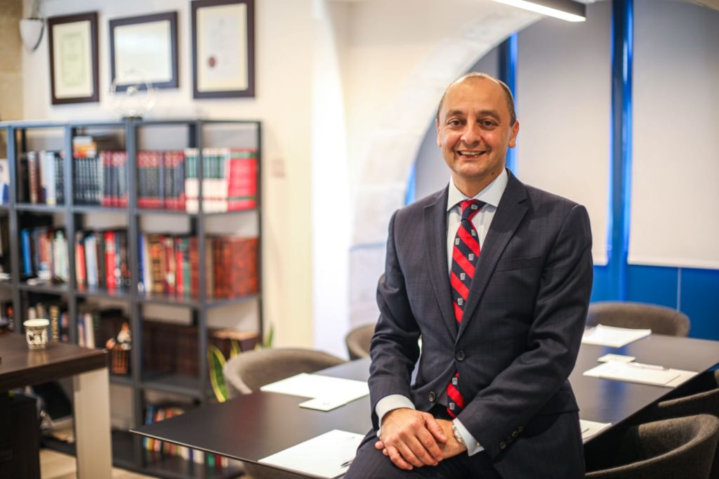
Andy Ellul
LM: What are some of the goals that the National Technical Committee will be aiming for?
AE: The NTC was set up following a joint initiative by the Family Ministry and the Justice Ministry.
In general, the NTC aims to:

  - Generate a body of, qualitative and quantitative, literature that specifically addresses Malta’s experience of the phenomenon of Parental Alienation;
  - Generate a clear understanding of local solutions, and any lags that appear to beset the current scenario in the address of Parental Alienation;
  - Generate a campaign that aims at educating the public about the nature of Parental Alienation, its distinguishing components, and the ill-effects towards minors;
  - Come up with a National Strategy to support the Government in developing future interventions that aim to ameliorate the local disposition to address parental alienation;
  - Develop a legal instrument to support the Family Court of Malta to give fair and adequate legal remedies to the victims of parental alienation;
  - Develop training opportunities for the professionals who can support victims of parental alienation and the perpetrators alike.
In brief, NTC should produce these deliverables:

  - A draft law
  - A national strategy articulated in an official manual
  - A register of media events
  - A register of dissemination sessions
  - A website adequately connected to a series of other social media platforms
  - A proposal for a service architecture
  - A structure for a training course
LM: In your opinion, what are the most serious aspects of parental alienation that we need to educate on?
AE: The suffering and the long-term harm or damage it causes to both the targeted parent and the minors involved.
LM: Finally, do you have any advice to parents who may feel like they are going through it as we speak?
AE: Parents should always respect the best interest of the child. Separating parents should learn more about co-parenting (FSWS offers courses on the subject). They should steer clear from defaming the other spouse with their children. Children should never be used as pawns to hurt others, even though it may sometimes give a brief feeling of retribution. That brief feeling however may cause the child long term harm.
By way of conclusion, the Technical Committee will study further the phenomenon of parental alienation and introduce remedial measures to it in order to help those targeted parents as well as children victims. There are numerous studies showing that parental alienation is the cause behind mental health disorders and suicides in parents.
Tackling parental alienation would be helping those parents who feel powerless in the way the alienators manipulate the justice system around them. Legislative changes will ultimately strengthen the authority of the courts and will pave the way for justice to be truly done in such sensitive cases

Have you been affected by parental alienation in Malta? Contact us in confidence by emailing johnathan@lovinmalta.com - Johnathan Cilia

